
Critical Analysis Task
Name: Jeebak Sabu
Student ID: 48085847
Course Code: COMP2200
Word Count:

Table of Contents
Introduction 3
Task 1: Choosing a Centrality 4
Why Betweenness? 4
How It All Fits the VC’s Goal 4
Task 2: Identifying 4 Code Repairs 5
1. Named Aggregation for Demographics 5
2. Enhancing Log-Log Board-Count Distribution Plot 5
3. Validate & Clean Clustering Inputs 7
4. Enhance the Age vs. Compensation Scatter Plot 8
Task 3: Exploring Unused Feature In The Dataset 9
Task 4: Complementary Dataset 9
Task 5: Refinement Options 10
Conclusion 12

Introduction
I am working as a data scientist for the same venture capital fund. After investing in a promising company, the partners now lament the time and wish to speed its exit by arranging a takeover from a wealthy U.S. public acquirer. To expedite that conclusion, they’ve entrusted you with mining the target firm’s board network, identifying the most powerful directors who can provide access to significant publicly traded firms. On your predecessor’s departure day, I discovered a Jupyter notebook and two CSVs with actual DEF 14A director filings: one mapping directors to CIK-coded corporations and the other listing each director’s age, gender, and annual remuneration.
This report runs through five tasks aimed to convert raw filings into actionable intelligence:
- Network Centrality Analysis entails creating a bipartite graph of corporations and directors, then calculating degree, eigenvector, and betweenness centrality to determine each director's strategic position.
- Code Improvements - providing specific fixes (e.g., pandas named aggregate, improved visualizations, input validation) to make our notebook more efficient, robust, and understandable.
- Feature Exploration entails revealing an underutilized role field (Chair, Independent Director, etc.) and displaying how it correlates with network impact.
- Complementary Data - Describes the integration of tenure-matched financial statements (via CIK and start/end dates) to assess each director's impact on revenues, assets, and profitability during their tenure.
- Presentation & Ethics entails creating polished, non-technical visualizations for stakeholders and considering the ethical implications of using personal and company data in boardroom intelligence.

Task 1: Choosing a Centrality

Why Betweenness?
Betweenness centrality emphasizes directors who connect otherwise disconnected board clusters exactly the brokers VC requires to unlock totally new company ecosystems.
- Degree Centrality
High: Serves on numerous boards, resulting in broad industry reach and an optimal number of introductions. These directors attend several board meetings, identifying opportunities across sectors.
Low: Few seats to deep, trusted links and ideal for high-impact, relationship-driven introductions. Their endorsements hold weight, but the number of possible introductions is limited.
- Eigenvector Centrality
High: Connected with other well-connected directors, resulting in endorsements from “hubs” and faster credibility. An introduction via them indicates to a board that you have insider support.
Low: Links to additional peripheral boards to a genuine but restricted doorway beyond local circles. Useful in specific domains but will not provide access to the larger ecology.
- Betweenness Centrality
High: Connects disparate board clusters, allowing access to new sectors without gatekeeper fatigue. These directors can carry your proposal from fintech to traditional financial networks.
Low: Stuck in one clique or on the fringe, leading to a loop of introductions within the network. Their influence rarely goes beyond their immediate surroundings.

How It All Fits the VC’s Goal
Degree - Shortlist directors with diverse backgrounds to increase initial contact volume.
Eigenvector - From that pool, prioritise those whose contacts themselves move deals amplifying credibility.
Betweenness - Finally, pinpoint the true brokers who bridge to untapped corporate circles, accelerating entry into entirely new networks.

Task 2: Identifying 4 Code Repairs

Named Aggregation for Demographics
Before:
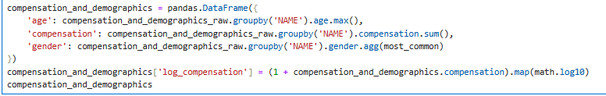
After:
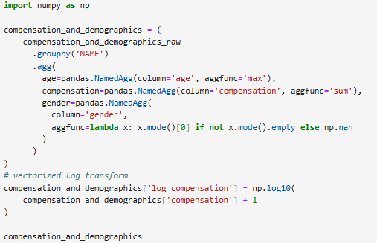
Why: Combines three passes over the table into a single clear block.
Benefit:
- Scan the DataFrame once for improved performance.
- Ensures that all directors are preserved (no quiet dropouts).
- Makes the intent clear for future maintainers.

Enhancing Log Board-Count Distribution Plot
Before:
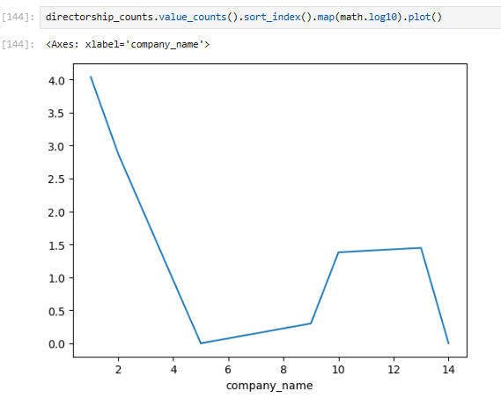
After:
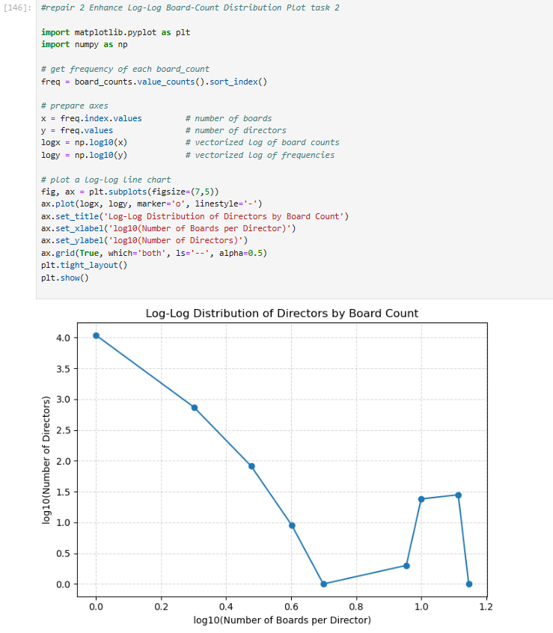
Why: Converts an unannotated default to a polished, legible chart.
Benefit:
The heavy tail is immediately apparent: most directors serve on a small number of boards, whereas a few serve on multiple boards. The axis labels, title, and grid make the distribution easy to understand for any audience.

Validate & Clean Clustering Inputs
Before:
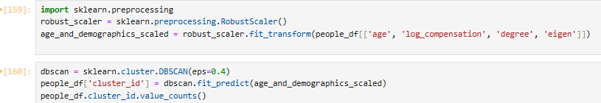
After:
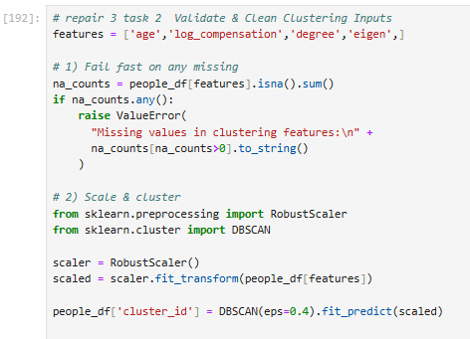
Why: To prevent NaNs from entering the scaler or DBSCAN.
Benefit:
It alerts you to errors, gaps in compensation, or centrality. Clustering operates without errors, and you know which rows require attention.

Enhance the Age vs. Compensation Scatter Plot
Before:
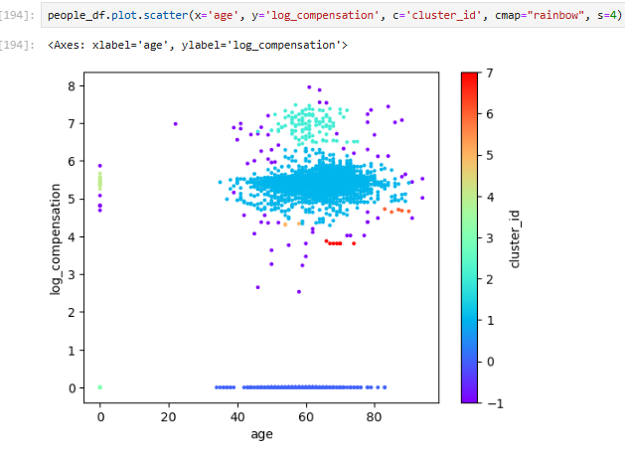
After:
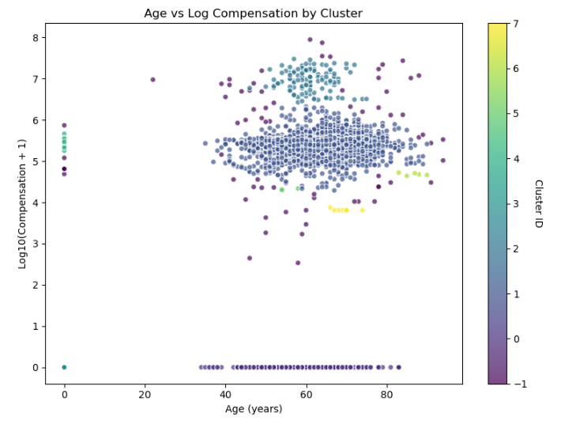
Why: Provides context (axes labels, title) and decodes colours using a colorbar.
Benefit:
Outliers and cluster separation are clearly highlighted and makes the graphic presentation-ready for non-tech stakeholders.

Task 3: Exploring Unused Feature In The Dataset
The role field provides an important qualitative dimension to our director profiles. Rather than treating each board seat identically, we can group directors by title Chairman, Independent Director, Executive Director, etc. and look for systematic disparities in their network positions. For example, chairmen frequently occupy the most prominent nodes (high eigenvector), indicating positions on highly networked boards. Independent Directors often rank highest in betweenness, serving as natural intermediaries between otherwise disparate business groupings. Executive Directors typically hold the highest degrees, serve on several boards, and make frequent introductions.
Incorporating role into our analysis is simple yet effective. We may stratify all graphs by role, allowing stakeholders to evaluate how formal titles correspond to influence. When clustering, a simple one-hot encoding of role, age, remuneration, and centralities ensures that groups reflect both network structure and board responsibility. Even at this early stage, role assists the VC in tailoring outreach engaging Chairmen for established, deep-pocketed networks and Independents to bridge across new industries.

Task 4: Complementary Dataset
Source : https://www.kaggle.com/datasets/dominicmalouf/sec-financial-statement-data-sets
Complementary Dataset: Tenure-Matched Financial Statements
To go beyond “who sits where,” I would use the SEC's Financial Statement Data Sets (e.g., the Kaggle sec-financial-statement-data-sets tables), which offer annual line-item filings (revenues, net income, assets, liabilities, cash, etc.) keyed by each company’s CIK. Using our existing cikcode, we can attach a complete history of balance sheets and income statements to each firm in company_directorships.csv.
Leveraging Director Tenure for Performance Analysis.
Because our CSV includes each director's start_date and end_date, we can determine which fiscal years they served on each board. We'd pull only those years’ financials for each director-company pair, then aggregate them across all their seats to calculate tenure-adjusted measures.
- Annualized growth rates (e.g., CAGR of Net Income and Assets) for each director’s portfolio of boards.
- Observed changes in leverage or liquidity (Liabilities/Assets, Cash) during tenure.
- Combining market data with stock-price returns over similar time periods.

Task 5: Refinement Options
- Please find the presentation on Github. The Visualization I used are the following
- Director counts by credibility tier
- Age Distribution of company directors
- Impact by role
- Top 10 directors by brokerage power
- In this analysis, we use publicly available board data to find “power brokers” who can expedite our VC’s exit by connecting us to new corporate networks. While this method has obvious financial benefits, it poses significant ethical concerns that must be addressed to ensure responsible data use and fair treatment of all parties involved.
- Respect for privacy and consent.
Public versus Private Data
All the information comes from DEF 14A filings, which directors have voluntarily disclosed to the SEC. We never use private or non-public information, and we never reveal compensation or demographic information that is not already publicly available.
Informed Outreach
When contacting directors, we should be transparent about how we received their information and why we believe their network position is valuable. Transparency at the first point of interaction promotes confidence and prevents the perception of hidden data collecting.
- Preventing Bias and Power Imbalances
Networks Bias
Centrality measures tend to Favor directors with extended tenures or high-profile positions on several boards. If we just focus on these “usual suspects,” we risk strengthening existing gatekeepers while ignoring emerging talent or marginalized views.
Inclusive Strategy
To address this, we may carefully include a mix of senior brokers and developing directors, ensuring that our outreach does not reinforce existing hierarchies or exclude new viewpoints
- Fairness and transparency
Clear Value Proposition
Every approach should emphasize reciprocal benefit: we're asking directors to help us connect, but we’re also providing them a role in designing a potentially revolutionary merger and acquisition. This two-way value exchange minimizes the likelihood that our request would be interpreted as solely transactional.
Disclosure of Intent
Be clear about the VC’s objectives and how introductions will be utilized. If a director is misled about the aim or scope of our initiative, the long-term relationship risk outweighs any short-term benefit.
- Long-term Relationship Building
Ethical stewardship
Directors are stewards of shareholder value and face reputational risk and each introduction reflects on them. We must respect each link, follow up properly, and keep them informed of the outcome.
Sustainable Deal Flow
We establish a virtuous cycle by combining data-driven targeting and true relationship management: ethical treatment leads to strong networks, which provide higher-quality possibilities for our venture capital business.

Conclusion
Over five focused tasks, we developed a comprehensive, data-driven roadmap for our VC’s hastened departure. Task 1 presented centrality measures degree, eigenvector, and betweenness to determine who can provide the broadest introductions, the most prestigious endorsements, and critical bridges into underserved business clusters. In Task 2, we significantly enhanced the usability and speed of the Jupyter notebook by reducing unnecessary group-by operations, supplementing charts with explicit annotations, validating inputs before clustering, and decorating scatter plots to emphasize essential patterns. Task 3 then introduced the “role” feature (e.g., Chairman, Independent Director) to provide a qualitative dimension, demonstrating how formal titles correlate with network impact. For Task 4, we recommended combining SEC financial files (connected by CIK) to assess how directors’ board service affects firm performance over time. Finally, in Task 5, we turned these findings into a visually appealing slide deck for non-technical stakeholders and developed an ethical framework to ensure our outreach is transparent, fair, and based on publicly available data. Together, these stages provide a powerful yet principled strategy for utilizing board networks to accelerate the sale.

